Quantum Fiber – Working with Salesforce Cases (QF Tech Assist)

Table of Contents

1.0 Overview 3
2.0 Effective Date 3
3.0 Related Links 3
4.0 What is a Salesforce Case? 4
5.0 Checklist 4
6.0 Creating Cases in Salesforce 5
6.1 Case Record Types and Subtypes 8
6.2 Status 19
6.3 Caller Name 19
6.4 Subject 21
6.5 Notes 21
6.6 Description 21
6.7 Case Owner 21
6.8 Click to Call Case 22
7.0 Case Sub Status 22
8.0 Reassign Case and Changing Ownership 22
8.1 Reassigning a Case to a Person 25
9.0 Escalate 28
10.0 Document Management 29

Overview

Target Audience | QF Facility Support | QF Programming
Impact/Benefit | Cases in Quantum Fiber Salesforce (QFSF) are used to track work and notify other groups that additional work needs to be completed. This document outlines how to correctly create a case when handling fallout.
Reason for Change | Updated the Tech Assist section per as part of the transition to Forged Fiber 37, newly created Technician profiles will no longer utilize CUID’s. Request the Technicians to provide their name as appears in the Company Directory.

Effective Date

Effective Date | Expiration Date
09/02/21 | Until Further Notice

Related Links

Link and Name
Link to QFSF: Quantum Fiber Salesforce – Log In
Quantum Fiber - Salesforce Overview (QF Tech Assist and QF Structure Load) .docx
Sales Force Case Remarks.xlsx
Quantum Fiber – Splitter Capacity Issues & 1GIG Capability – (All Markets)
Quantum Fiber – View Transport Access Path in Optius (All Markets)
Quantum Fiber – Add and Update an Individual Address in O2 (All Markets)
My Support Desk - Quantum Fiber Optius/ODiN Support
Quantum Fiber - UDIF Values in Optius (QF Tech Assist)
Quantum Fiber - Manual Handling Post Migration Fallout (All Markets)
Quantum Fiber - Click to Call (QF Tech Assist).docx
Quantum Fiber - How to work Held orders in Optius (QF Tech Assist).docx
Visit the library to view all documents: https://centurylink.sharepoint.com/sites/NAOLibrary

What is a Salesforce Case?
Cases are a powerful tool within Salesforce used for recording, tracking, and resolving issues. Cases facilitate interactions with customers, other agents, or teams to communicate and solve problems that might prevent an order from being assigned, such as facility or engineering issues.

When a Quantum Fiber (QF) order cannot be completed due to company-related reasons requiring investigation, such as engineering or facilities issues, a Case is created to record, track, and resolve the problem. Additionally, automated cases may be generated based on specific error messages to address potential issues before the customer's due date, thereby preventing delays and avoiding unnecessary dispatches.

Cases are managed through Salesforce queues and can be routed to various departments, enabling effective communication and collaboration to resolve problems. Salesforce Case Management supports the recording, tracking, and resolution of customer issues through sales, service, and support channels. This functionality includes capabilities to create cases from emails (email to case), web forms (web to case), manually, or via automation.
Cases can be efficiently managed in queues with defined assignment rules and escalation protocols, ensuring timely and appropriate handling of issues.

Checklist
Step | Action
 | Verify if an open case exists that should be actioned.
Determine if a new case needs to be created and if so, create a new case.

Tip: Use the Excel file Sales Force Case Remarks to determine the correct Case Subtype to be used, as well as the required comments, etc. The link to this can be found in the Related Links section of this document.
Populate all necessary fields, for example:
- Case Type
- Subtype
- Status
- Subject
- Notes
- Description
Complete any additional action needed, for example:
- If case needs to be reassigned, reassign it
- If no other department or person needs to see the case, close it

Creating Cases in Salesforce
TIP! Before creating a new case check to see if there is an existing case on the account that should be used. If so, update the Case Owner and Case Type instead of creating a new case. See Subject below.

NOTE: Cases that have PDAP in the subject field should not be closed by QFTA. It is ok to modify the case, when appropriate (Tip: See the PDAP Cases section of this document.) Open a new case to account for the work or to send to another queue. If this Case Type is in the Facility Support queue, reassign it to the case creator. PDAP (Past Due Activation Project) is how Fiber Customer Success Team (FCST) tracks the past due and held orders to ensure it is followed up on and the customer is notified.

To see the entire Case history for an Account, select Cases in the Highlight Panel (in the Related List Quick Links section)

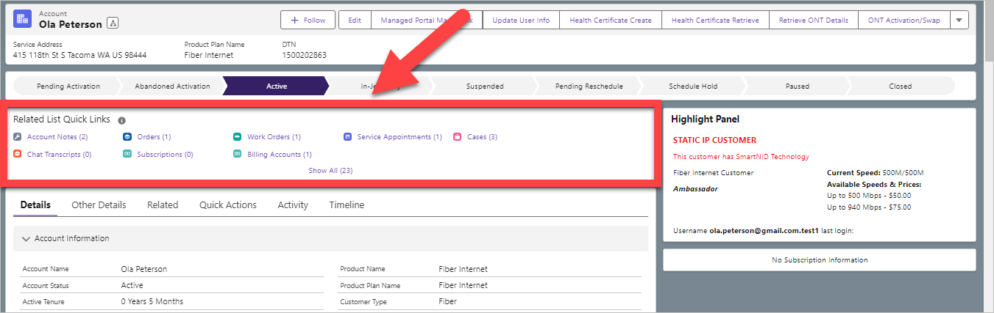

This will show any Case that has been created on the account, regardless of the Case Status (Open, Closed, Cancelled, etc.)

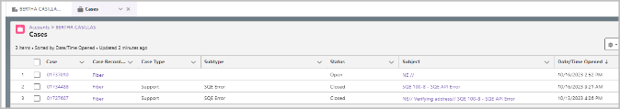

To see a list of cases in an Open status or to create a new case in QFSF go to the Account and select Quick Actions. Select the case number link(s) to view the case(s) to see if it should be actioned.

To see a list of cases in any status that are less than 30 days old that have an INC populated in the case go to the Account and select Quick Actions. Select the case number link(s) to view the case(s).

If an existing Open case cannot be actioned, a new case will need to be created.

Select the appropriate case Record Type to be created.

Important Tip: See the Case Record Types and Subtypes section of this document for more information and also use the Sales Force Case Remarks excel file (the link for this is in the Related Documents section) to assist in selecting Subtypes as well as guidance on what should be populated in the Notes and Description fields!

Select Continue.

NOTE: Once the Continue button has been selected, the case is now created. Additional action is required at this point to either route the case accordingly or close it. If case was opened in error, select Cancelled in the Status drop down and fill in any required fields, and include comments indicating the case is being cancelled because it was opened in error. Abandoned cases (cases with no Case Type or Sub Type) will be automatically deleted after 12 hours.

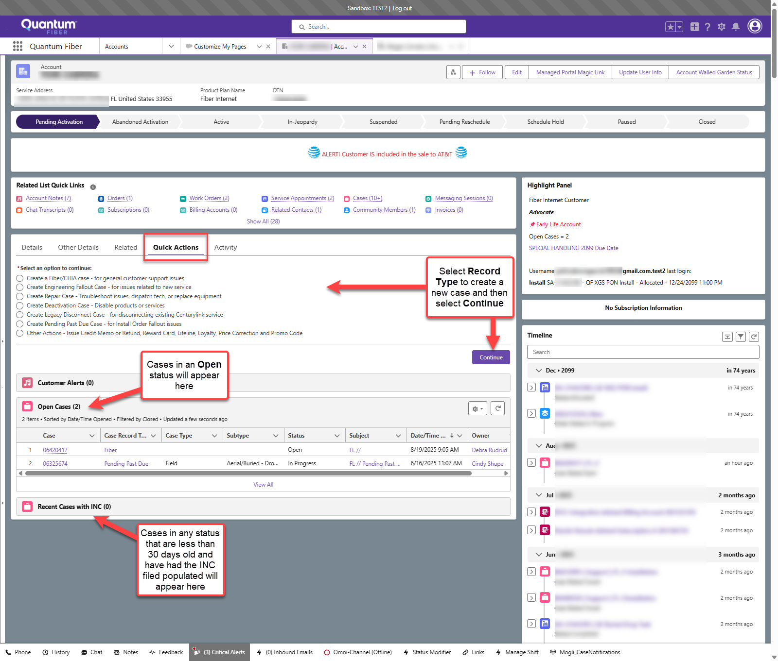

Fill in fields including:
- Case Type – see the Case Records Types and Subtypes section for more information.
- Subtype – see the Case Records Types and Subtypes section for more information.
- Status – see the Status section for more information.
- Caller Name – see the Caller Name section for more information
- Subject – see the Subject section for more information
- Notes – see the Notes section for more information
- Description – see the Description section for more information

Tip: If a Case does not need to be seen by anyone else, the agent can close the case by selecting a Status of Closed.

Then select Submit.

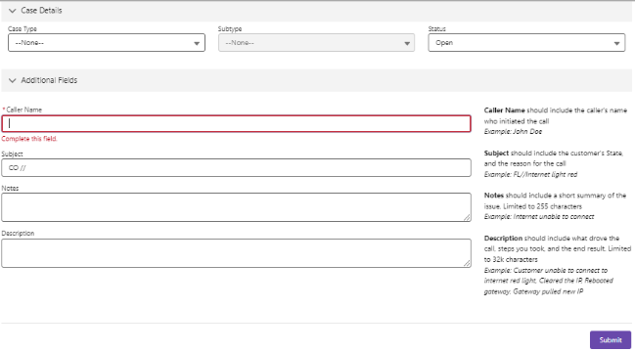

This will move to the next screen where additional information can be added or changed if needed.

Case Record Types and Subtypes
Different Case Record types will have different options/requirements and will also have different Subtypes.

The current Case Record Types are:
Note: This is the comprehensive list and does not mean QFTA would use all of these.
Tip: A screen grab displaying the Quick Actions tab if can be seen in the Creating Cases in Salesforce section if needed.
- Create a Fiber/CHIA case - for general customer support issues
  - CHIA = Consumer HSI Integrated Architecture
- Create Engineering Fallout Case - for issues related to new service
- Create Repair Case - Troubleshoot issues, dispatch tech, or replace equipment
- Create Deactivation Case - Disable products or services
- Create Legacy Disconnect Case - for disconnecting existing Centurylink service
- Create Pending Past Due Case - for Install Order Fallout issues.
- Other Actions - Issue Credit Memo or Refund, Reward Card, Lifeline, Loyalty, Price Correction and Promo Code

Fiber/CHIA case
Select Create a Fiber/CHIA Case – to:
- Create a Callback case
- Create a Facilities Support/Programming case
- Create a Tech Assist case
- Create an Engineering Records Correction (This can also be done by selecting Engineering Fallout instead of Fiber/CHIA)

There are other Case Types available, but QFTA will only use these. All Fiber/CHIA cases have a Caller Name field. See the Caller Name section for more information

Case Type – Case type should be selected based on the reason for creating a case.

Callback
Creating a Callback case anytime a customer needs to be contacted should no longer be the default action taken.

Automated communication thru Contact Engine should be used as much as possible when a customer needs to be contacted, to eliminate unnecessary manual touches by FCST. See the PDAP Cases section of this document for more information.

A Callback subtype should only be selected when it meets one of the following criteria:
- There is an address issue that requires clarification from the customer
  - E.g. missing unit or address correction requiring cancel and recreation of order.
Note: DO NOT create order in O2 as this will cause order fall out later.
- There is Other Working Service (OWS) in Quantum Fiber (Use Legacy Disconnect case for OWS in Legacy)
- A case was falsely routed to Facility Support when it should have gone to Callback

Use a Subtype of Company Initiated

Important Tip: See the Sales Force Case Remarks excel file (the link for this can be found in the Related Documents section of this document) to assist in selecting Subtypes as well as guidance on what should be populated in the Notes and Description fields!

Facilities Support/Programming
Effective the December 12th, 2024 release, QFTA will no longer use the Case Type of Support.
Note: The Dec 12th, 2024 release had problems and was reverted. This release was re-implemented on Jan 16th, 2025.

All Subtypes used by QFTA that were previously under a Case Type of Support have been moved to a new Case Type of Facilities Support/Programming.

This should be selected anytime work is being done that does not consist of a call coming in through the queue. Any call activity should be captured under a Case Type of Tech Assist.

- A case should be created for every DTN including Bulk Property.
- The Subtype should be selected from the drop-down list using the appropriate corresponding subtype reason.

Important Tip: See the Sales Force Case Remarks excel file (the link for this can be found in the Related Documents section of this document) to assist in selecting Subtypes as well as guidance on what should be populated in the Notes and Description fields!

Tech Assist
Tech Assist should be selected anytime an agent manages a phone call or chat, including from Fiber Customer Success Team (FCST) as well as Technicians.

- A case should be created for every DTN, including Bulk Property.

- The Subtype should be selected from the drop-down list using the appropriate corresponding subtype reason.

- Selecting a Case Type of Tech Assist will also require the agent to verify the Tech that is being spoken to in order to fill in the Additional Fields section.
  - If the Tech is the same Tech that is assigned the Service Appointment (SA), then the agent can select the SA option that should already display that technician’s name.

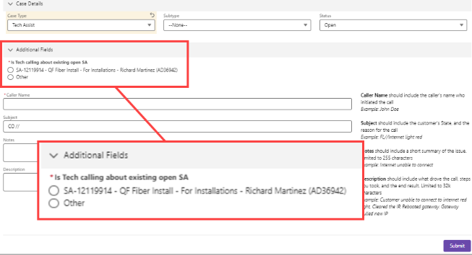

- If that is not the Tech that is calling in, the agent should select the Other radio and start typing in the Techs name until the desired result becomes selectable, or the CUID can be entered and searched by entering the CIUD information, selecting the Show all Results for ____.
  - Note: As part of the transition to Forged Fiber 37, newly created Technician profiles will no longer utilize CUID’s. Request the Technicians to provide their name as appears in the Company Directory.
- If the caller is a customer, the agent should populate the agents own name.

Verify the Tech name is the correct Tech.

Select the corresponding result.

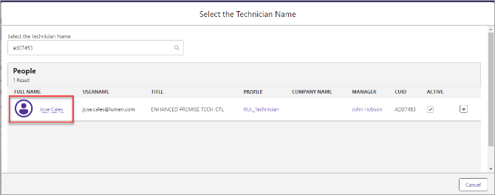

Once the remaining information is entered select the Submit button.

Then it will go to the next screen where it will display the technician’s name that was entered on the prior screen. It also links that case back to the Service Appointment (SA) that was related to the case.

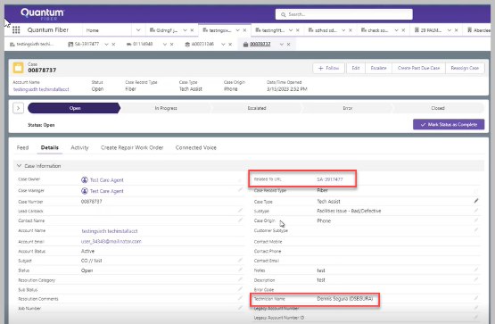

Tech Assist Subtypes
When selecting the Subtype it should indicate the first action taken to resolve the Technician’s issue.

When an agent is cross trained, the agent can use both Facility Support and Programming subtypes based on the action being performed.

This means a Programming agent can use Facility Support subtypes, and Facility Support agent can use Programming subtypes, when those actions are being taken.

Important Tip: See the Sales Force Case Remarks excel file (the link for this can be found in the Related Documents section of this document) to assist in selecting Subtypes as well as guidance on what should be populated in the Notes and Description fields!

Error encountered using T2G-activate ONT
When one of the following Subtype’s is selected:
- Programming – Activate ONT
- Programming – SmartNID
- Programming – Swap ONT

an Error encountered using T2G-activate ONT drop-down menu will appear.
Verify with the Technician why the Tech could not use T2G (Tech 2 Go) to complete the necessary steps and select that corresponding reason from the drop-down menu.

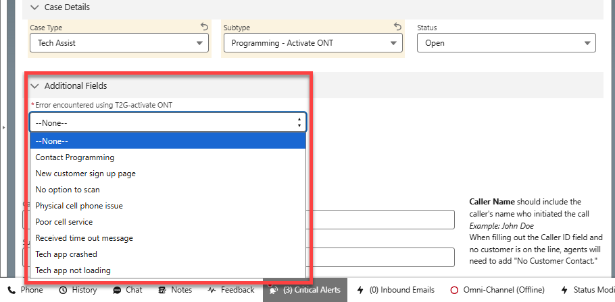

Internal Assist
Internal Assist should only be selected when assisting FCST or other internal non-technician personnel.

Important Tip: See the Sales Force Case Remarks excel file (the link for this can be found in the Related Documents section of this document) to assist in selecting Subtypes as well as guidance on what should be populated in the Notes and Description fields!

Selecting a Case Type of Internal Assist will also require the agent to populate the name of caller in the Technician/Internal Agent field.

Either select the corresponding result, or to see a list, select the Show more results for option

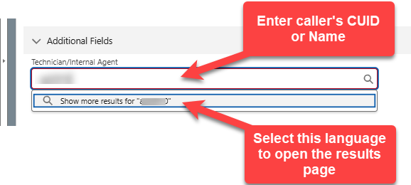

Verify the name of the caller is correct.

Select the corresponding result.

Select the Select button at the bottom of the screen.

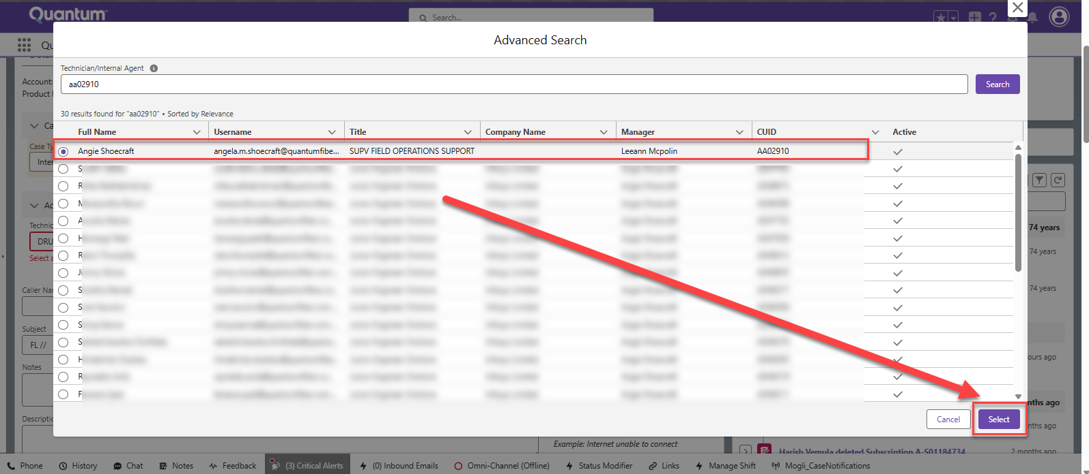

Engineering Fallout Case
Select Create Engineering Fallout Case - for issues that require engineering review.

Important Tip: See the Sales Force Case Remarks excel file (the link for this can be found in the Related Documents section of this document) to assist in selecting Subtypes as well as guidance on what should be populated in the Notes and Description fields!

Case Type (select based on reason for case creation):

Customer Address Fallout
  - QF Tech Assist will not use this Case Type.

Engineering Fallout
  - Subtype should be selected from the drop-down list using the appropriate corresponding subtype reason.

Engineering Records Correction
  - This Case Type was added in the August 25, 2023, Salesforce Release and will be used to communicate any records corrections that need to be sent to Engineering. Subtype should be selected from the drop-down list using the appropriate corresponding subtype reason.

Planning Fallout
  - Select a Subtype oF Splitter Exhaust any time there is a Splitter exhaust or OLT exhaust issue.

Note: For Splitter Capacity Issues, see document Quantum Fiber – Splitter Capacity Issues & 1GIG Capability – (All Markets) Link is in Related Documents.

Repair Case
Currently, this case type is not used by QFTA

Deactivation Case
Currently, this case type is not used by QFTA

Legacy Disconnect Case
When there is a conflict with Other Working Service (OWS) and the OWS is a Legacy customer, a Legacy Disconnect Case will need to be created.

After selecting Create Legacy Disconnect Case this screen will appear:

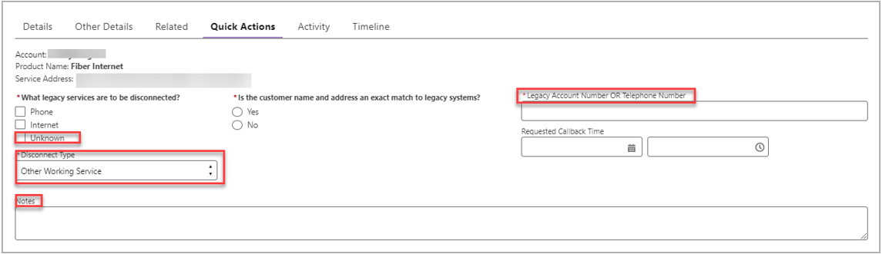

  - Disconnect Type
    - Select the appropriate Legacy Service
Note: the option of Unknown has been added
  - Is the customer’s name and address an exact match to legacy systems?
    - Select No, which will cause the Provide alternate details field to appear
      - Input Unknown
  - Legacy Account Number
    - Input the Legacy Phone Number
  - Requested Callback Time
    - Do not action these fields
Select Continue.

On the next screen add notes and update the Subject field.
In the Notes field input: OWS for Legacy
In the Subject field: update by adding /OWS at the end

Select Save.

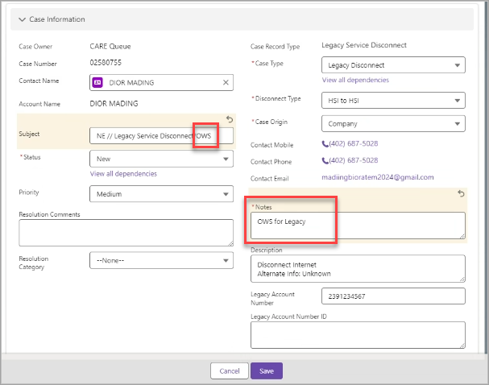

Pending Past Due Case
This case type is only able to be created by agents with the appropriate permissions.
Previously this case type wasn’t touched by QFTA, but this is no longer true.
When QFTA is working on a Past Due order and is able to resolve it, check to see if a Pending Past Due case exists and is in an Open/Pending type of status (i.e. Not Closed/Canceled), and if so, update it as described in the PDAP Cases section of this document.

When trying to use this case type and do not have permission, it will display message:

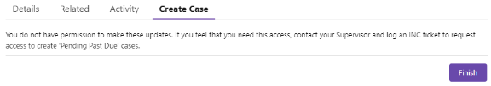

If an agent does have permission, it will create that case type & move forward to the next screen:
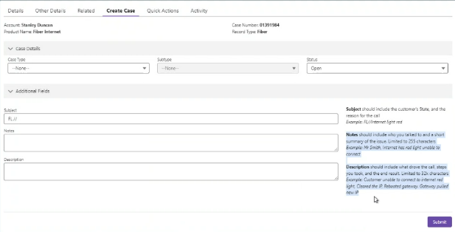

See the PDAP Cases section of this document for how to update these existing cases.

PDAP Cases
Past Due Activation Project (PDAP) is a specialized team within FCST and is past due and held orders are tracked to ensure it is followed up on and the customer is notified.

Previously QFTA did not touch PDAP cases. This is no longer true!

To best utilize automated communication with the customer via Contact Engine, QFTA will now action PDAP cases under certain circumstances. To see those details, please see the Quantum Fiber - How to work Held orders in Optius (QF Tech Assist) document, the link for which can be found in the Related Links section of this document.

In order to update a PDAP case

If | Then
Working on an Order that has a past due due date, there should be an existing case with a Case Record Type of Pending Past Due and if the order is assigned/the issue was resolved | - Verify the case Status is Open/In Progress (not Closed or Cancelled)  - When viewing the case, select Feed, then select Post and add comments. Then select Share to post the comments.  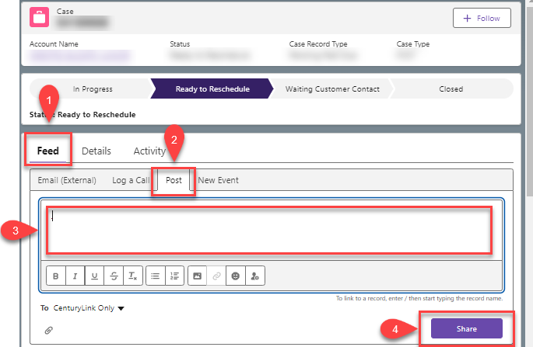  - Go to the Service Appointment (SA) and locate the Time Constraints (User Timezone) section.  Verify all four Date fields display 12/25/2021 (Note: the time doesn’t matter).  - If the Date isn’t 12/25/2021, use the Edit pencil to update it to 12/25/2021 & save the change.  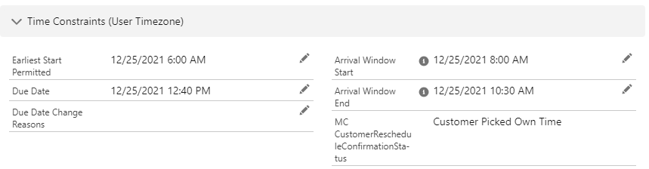  - Go back to the Pending Past Due case.  - Update the Status to Ready to Reschedule.  - Verify/Update the Case Type to FCST  - Verify/Update the Subtype to Waiting on Customer  - This will trigger an automated Contact Engine communication to the customer to reschedule.  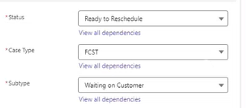
Working on an Order that has a past due due date, there should be an existing case with a Case Record Type of Pending Past Due and if the order is not assigned/the issue was not resolved | - Verify the case Status is Open/In Progress (not Closed or Cancelled)  - When viewing the case, select Feed, then select Post and add comments. Then select Share to post the comments.    - If the issue was not resolved and needs to go to another department for resolution (ex Engineering), be sure a case is routed to that department.  - The PDAP agent will send follow up communication to the customer.

Other Actions - Issue Credit Memo, Reward Card, Lifelink, Loyalty, Price Correction and Promo Code
This case type is not currently used by QFTA.

Status
Use the following Case Status accordingly:
  - Open - if the ticket is being routed to another department or if Agent work isn’t complete.
  - Closed - if the ticket has been completed.
  - Cancelled - if opened in error

Caller Name
This field will appear on the following case types:
- Fiber/CHIA
- Engineering Fallout
- Repair (not used by QFTA)
- Deactivation (not used by QFTA)

If there is no related call, input N/A in the Caller Name field.
(Note: this would mean the Case Type being used is not Tech Assist)

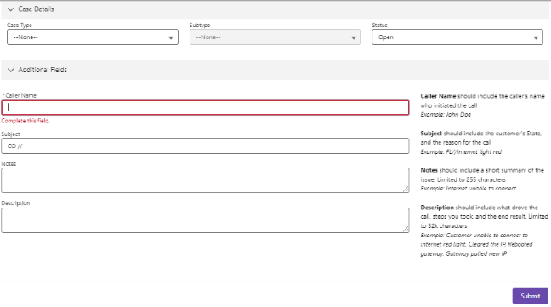

If the case is related to a call or chat, input the same information as what is being populated in the Is Tech calling about existing open SA field on the Tech Assist case.
Tip: can copy and paste.

Note: this would mean the Case Type being used is Tech Assist.

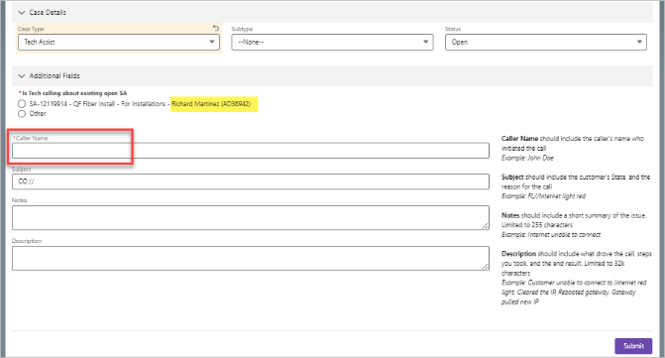

Subject
2-character State abbreviation/Department/other information providing brief summary of reason for case
Example:
- CO/QFTA/Address Fallout
- FL/QFTA/Red E
Tip: Department is QFTA

Important Tip: See the Sales Force Case Remarks excel file (the link for this can be found in the Related Documents section of this document) to assist in selecting Subtypes as well as guidance on what should be populated in the Notes and Description fields!

Notes
A brief summary of relevant information.
This field is limited to 255 characters.
- Examples:
  - input reason for technician engagement
  - input fallout reason
  - changed Leg
  - changed MST
  - programmed ONT
  - splitter is full
  - MST is full

Important Tip: See the Sales Force Case Remarks excel file (the link for this can be found in the Related Documents section of this document) to assist in selecting Subtypes as well as guidance on what should be populated in the Notes and Description fields!

Description
Input detailed information including a summary of the situation, actions taken and results.
This field is limited to 32,000 characters.

Important Tip: See the Sales Force Case Remarks excel file (the link for this can be found in the Related Documents section of this document) to assist in selecting Subtypes as well as guidance on what should be populated in the Notes and Description fields!

Once all required criteria have been filled in, the Agent will select the Submit button.

This will move to the Details screen.

Case Owner
Agent will need to make appropriate selection from the drop-down list and select the Save button.

Case Owner will default to the creator of the case. To change ownership or to Reassign the Case, see the Reassign Case and Changing Ownership section below.

Click to Call Case
Quantum Fiber technicians will use the Tech2Go app to create a Click to Call case that triggers a call for assistance. The case and call are sent to internal Call Centers (QF Programming, Facility Support, Fiber Customer Success Team, or Dispatch). The Click to Call case will pop open on the Quantum Fiber Salesforce (QFSF) page, and the call will come through QFSF Genesys. For details, review Quantum Fiber - Click to Call (QF Tech Assist) document in Related Links section.

Case Sub Status
This was created for and will only be used by a specific team within the FCST.
This will not be used by QFTA.

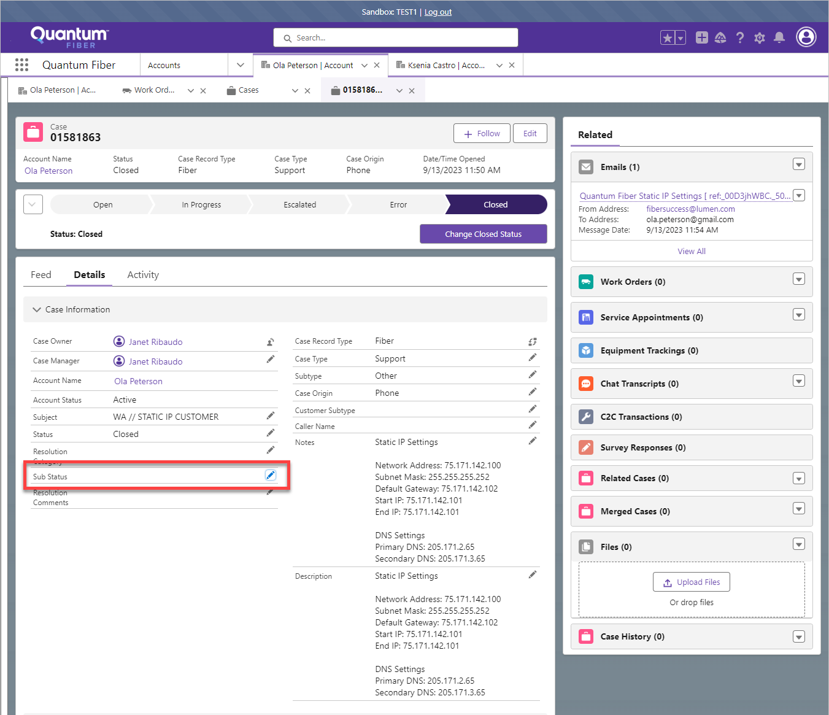

Reassign Case and Changing Ownership
Once a case has been created, it can be reassigned to a different department by using the Reassign Case button.

In the rare occasion that a Case needs to be reassigned to a person, see the Reassigning a Case to a Person section of this document.

Open the case that changes need to be applied to and select Reassign Case.

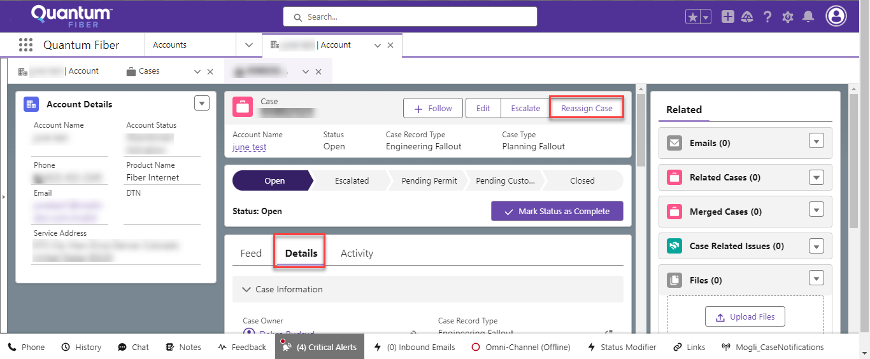

Note: If selecting Change Owner button to change the Case Owner to a different queue, an error message will display:

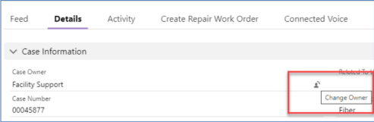

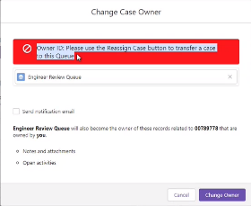

The Reassign Case screen will appear. Select the appropriate Reassign To option:
- Engineering Review - all issues that require Engineering review.
- Planning Queue – Splitter exhaust and OLT exhaust issues.

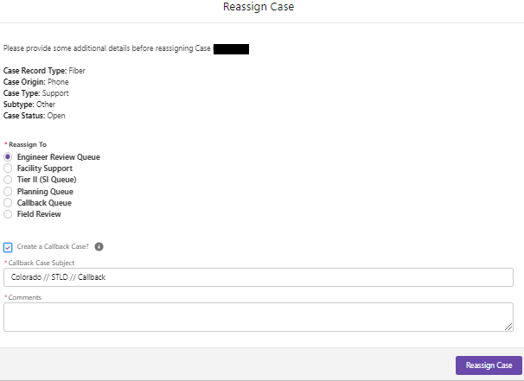

If a Case is being Reassigned to anyone other than Callback Queue, the agent will need to determine if a separate Callback case is required for additional action such as the Callback/FCST group needs more information, etc. Selecting the Create a Callback Case box will associate the Callback case to this case for tracking and report purposes. (See screen grab below)

Tip: Before selecting the Create a Callback Case? box, read the Callback section of this document to determine if a Callback case is needed.

Leave a detailed comment in the Comments box.

Select the Reassign Case button.

When using Case Record Type: Engineering Fallout, the Agent must indicate if the issue is related to a migrated address from the drop-down menu. Select the appropriate Case Type and Subtype. Select Reassign Case button.

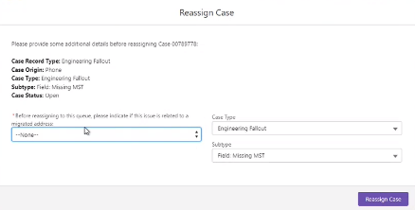

Here is an example screen grab of Callback Case in the Additional Information section showing the association to the Parent Case:

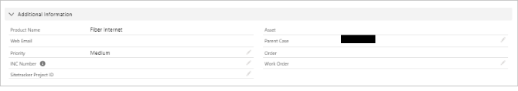

Reassigning a Case to a Person
There may be rare instances where reassigning a case to a specific person is needed.
The only valid scenario of this currently, is when the Case is on a Bulk Property account and the case needs to be reviewed by the LPM.

Examples of this would include:

When the Notes say:
- Sasktel Service Order Assign call failure
  - The process failed before even attempting to create the order in Optius, therefor this is not a valid Facility Support case, and the Case should be reassigned to the LPM.
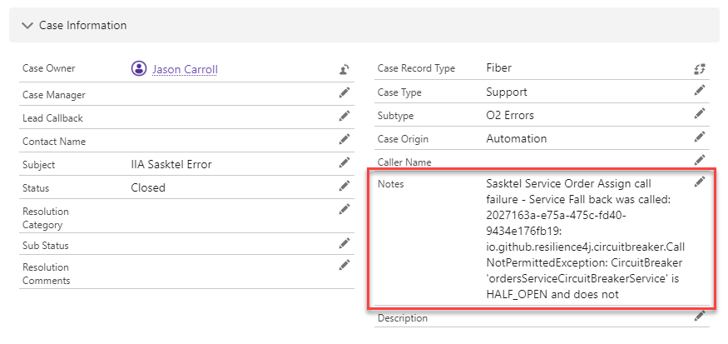

- SASKTEL:UNABLE_TO_COMPLETE : 30124 - ODiN - Unable to assign resources, reason: ME=12487 RACHAEL DR does not have available ports
  - This ODiN error will still be valid to fallout to Facility Support, however this happened due to OWS and subsequent CIASN order pended. This happened before the Aug IIA tool automation will resolve NEW instances of this fallout, however older manual fixes will be required
  - This error happened because the ONT is full. Is possible in other scenarios that the ENG design needs to be updated if more addresses were assigned to the ONT than the ONT is capable of supporting, or the ONT size may need to be changed. The LPM and the ENG will work together to resolve the issue. Reassign the case to the LPM.

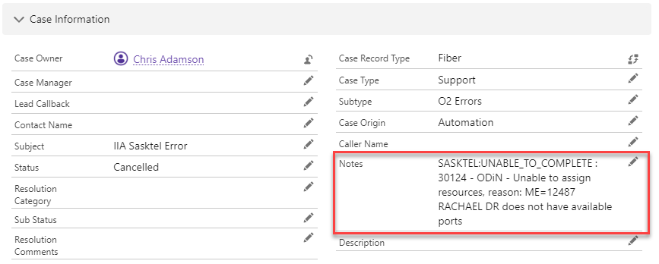

If there are other cases that shouldn’t be assigned to Facility Support, please reach out to report them.

To reassign a case to a person, select the Change Owner icon on the right side of the Case Owner line.

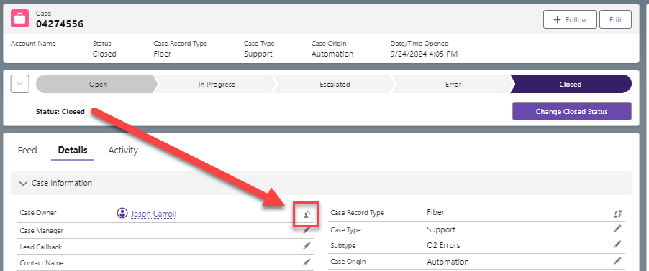

Begin typing the name of the person that the case is being reassigned to.
Select the corresponding name in the results suggestions below.

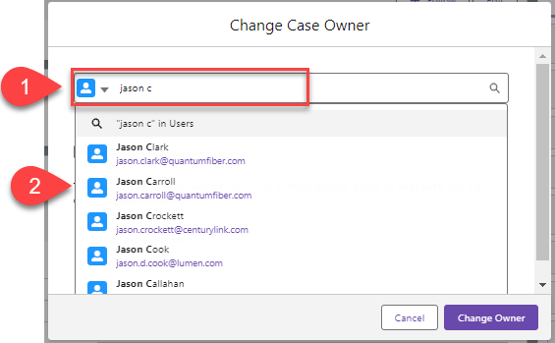

Important! Be sure to select the Send notification email box.
This is important as LPM’s currently do not monitor Cases, and this will be the only way an LPM will know there is a Case for that LPM to review and action.
Then select Change Owner.

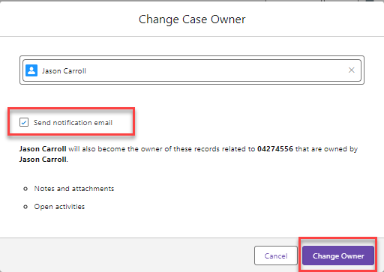

Escalate
The Escalate/Escalated buttons should not be selected by QFTA, unless following the Quantum Fiber - New Build Not Ready Escalation Process (QF Structure Load) process. The NBNR process is the only time that QFTA should be escalating a case.

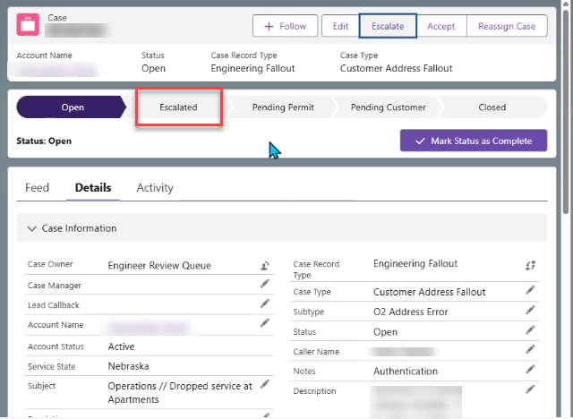

Document Management

Document Management
AUTHORS
Author | SME |  | Name |  |  | Telephone Number | E-mail Address
X |  |  | Debra Rudrud |  |  | 608-615-4215 | Debra.Rudrud@lumen.com
REVISIONS
Date |  | Issue |  | Revised By |  | Comments
04/12/22 |  | 1 |  |  |  | Initial Version
04/14/22 |  | 2 |  | Tammy Balsley |  | Removed Planning Queue – all capacity issues will now go to Engineering Review
01/20/23 |  | 3 |  | Debra Rudrud |  | - Adding January 20, 2023 - Release Enhancements:  - Renamed Create Support Case to Create Case  - New Cases must be created on the Account tab.  - New Case Types and Subtypes  - Agents must use the Reassign Case button to send existing cases to the appropriate Queue.  - Changed Document Author from Tammy Balsley to Debra Rudrud. Changed Approval Manager
02/24/23 |  | 4 |  | Debra Rudrud |  | Added February 17, 2023, Salesforce release enhancements.  - The Prodapt case type was removed.  - Description field when opening a case was changed to Notes field, and the 255-character limit will no longer allow additional characters to be typed, avoiding error message.  New Record Type was added
04/27/23 |  | 5 |  | Debra Rudrud |  | Changed format & added March 17, 2023, Salesforce Release updates including Notes field added on Create Case screen and change to Tech Assist case screen. Also added note about Planning Fallout Case Type for clarity. Added Link to supporting process Quantum Fiber – Splitter Capacity Issues & 1GIG Capability – (All Markets)
07/06/23 |  | 6 |  | Debra Rudrud |  | Updated link for Quantum Fiber – Programming-Structure Load Subtypes for Tech Assist Cases (All Markets) document as Structure Load information was added to that document recently.
08/22/23 |  | 7 |  | Joela Flaxa |  | Add Quantum Fiber – Manual Handling Post Migration Fallout (All Markets) to related documents, modified format for Notes and Description section with examples.
09/08/23 |  | 8 |  | Debra Rudrud |  | Updated to add new Engineering Records Correction case type. Also updated to discontinue use of Legacy Disconnect case type.
10/16/23 |  | 9 |  | Debra Rudrud |  | Updated to reflect changes due to the 10/13/23 Salesforce Release. Changes include where to navigate to in order to create a new case & how to see cases in an Open status only.
11/01/23 |  | 10 |  | Debra Rudrud |  | Updated how to search for a Tech by CUID when tagging a specific Tech to the case.
12/18/23 |  | 11 |  | Debra Rudrud |  | Updated to include the new Caller Name field on Fiber/CHIA cases. Also, merged document Quantum Fiber – Programming-Structure Load Subtypes for Tech Assist Cases (All Markets) into this document, and document Quantum Fiber – Programming-Structure Load Subtypes for Tech Assist Cases (All Markets) has been archived.
01/18/24 |  | 12 |  | Debra Rudrud |  | Updated to include the new Case Type’s that will include the Caller Name, and updated Legacy Disconnect cases being restricted. Both updates are due to January Salesforce Release updates.
02/08/24 |  | 13 |  | Joela Flaxa |  | Updated to provide case note templates.
03/15/24 |  | 14 |  | Debra Rudrud |  | Updated to reflect March 14, 2024, QFSF Release updates including:  - New screen grab showing Related List Quick Links new location  - New Tech Assist Case Subtypes  - Programming – Swap ONT  - Programming – Verified Programming  Corrected language of Case Record type from Issue Reward Card to Retention Process – Issue Credit Memo, Reward Card  Updated to include information about Case Sub Status.  Updated Quick Actions screen grab (on page 6)  Non-release update: The Legacy Disconnect Case has been made usable again.
04/15/24 |  | 15 |  | Debra Rudrud |  | Updated/corrected Links in Related Documents section.
04/19/24 |  | 16 |  | Joela Flaxa |  | Updated to reflect the 4/19/24 enhancement to Legacy Disconnect case to account for when a case type need created and disconnect details are unknown.
06/05/24 |  | 17 |  | Debra Rudrud |  | Updated information for the Tech Assist Programming Subtypes (Activate ONT and SmartNID)of section based on ONT type
08/20/24 |  | 18 |  | Debra Rudrud |  | Added context that when selecting a Subtype the agent should choose based on the first action take to resolve the Technicians issue.
11/11/24 |  | 19 |  | Debra Rudrud |  | Made the following updates:  - Updated all department references from Programming, TSC, and Structure Load to QFTA.  - Added context that when selecting a Subtype the agent should choose based on the first action taken to resolve the Technicians issue.  - Removed language that QFTA does not touch PDAP cases, per we have now agreed to avoid casing to Callback when Contact Engine can auto-communicate to the customer. This has also resulted in updates to the Callback section and adding the PDAP Cases section.  - Added context for when using Callback, Support, and Tech Assist case types to better define when they should be used as well as Notes requirements, etc  - Added two new Tech Assist subtypes being deployed in the November release:  - Programming – Authentication Issue  - Programming – Migration Issue  - Added the Reassigning a Case to a Person section and when re-assigning a Case to a person instead of a team that the Send Notification Email box must be checked.  - Combined Tech Assist subtypes instead of having separate lists for Programming, Facility Support, and Support, as any agent can use these when appropriate.  - Added these three existing Tech Assist Support Subtypes:  - Support – Dropped Call  - Support – Misdirect  - Support – Outage
12/11/24 |  | 20 |  | Debra Rudrud |  | Updates for the Dec 13th, 2024 Integrated Release:  (Note: The Dec 13th, 2024 release was reverted due to problems, and was re-implemented on Jan 16th 2025.)  - The following Subtypes under Case Type of Support were removed:  - Programming – Other  - Other  - A new Case Type of Facilities Support/Programming was created, and  Subtypes used by QFTA were moved from Support to Facilities Support/Programming  - The following new Subtypes under Case Type of Facilities Support/Programming were created:  - Programming – ICR  - Facility Support – Escalation  - Programming – Escalation  - When a Case Type of Tech Assist is selected and a Subtype of either Programming – Activate ONT or Programming – SmartNID is selected a new Error encountered using T2G-activate ONT field will appear where the QFTA agent will populate the reason the Tech indicates that the Tech was unable to activate the ONT themselves.
01/23/25 |  | 21 |  | Debra Rudrud |  | The Case Type of Facilities Support/Programming with a Subtype of Migration Conflict is being re-named to a Subtype of Facilities Issue – Migration Issue in the Jan 28th 2025 Integrated Release.
03/6/25 |  | 22 |  | Debra Rudrud |  | Made the following changes:  - Removed link to archived document: Quantum Fiber SalesForce BIWF (All Markets).  - Replaced with link to the new doc: Quantum Fiber - Salesforce Overview (QF Tech Assist and Structure Load)  - Deleted the section Accessing Quantum Fiber Salesforce (QFSF) per that content is now located in the Quantum Fiber - Salesforce Overview (QF Tech Assist and Structure Load) document  - Deleted the section Searching in QFSF per that content is now located in the Quantum Fiber - Salesforce Overview (QF Tech Assist and Structure Load) document  - Deleted the Prodapt Queue section of this document per the Prodapt queue was removed on 2/17/23 and will no longer be used.
03/17/25 |  | 23 |  | Debra Rudrud |  | Inserted the What is a Salesforce Case? section and archived the document QF Salesforce Case Management (All).docx. Also added info about escalating cases.
04/10/25 |  | 24 |  | Yolanda Garner |  | Add new subsection Click to Call Case in section 5.0 Creating Cases in Salesforce.
05/22/25 |  | 25 |  | Debra Rudrud |  | Added the link to the Quantum Fiber - How to work Held orders in Optius (QF Tech Assist).docx document in the Related Links section.  Updated the Planning Fallout section and the Reassign Case and Changing Ownership sections as relates to the new directive that QFTA can case Planning for Splitter Exhaust or OLT Exhaust issues.
07/09/25 |  | 26 |  | Debra Rudrud |  | Added the Checklist.
08/20/25 |  | 27 |  | Debra Rudrud |  | Updates for the August release changes. Added the Error encountered using T2G-activate ONT section, the Internal Assist section, and the Recent Cases with INC section. Updated the Case Type of Customer Address Fallout to indicate that QFTA will no longer use that Case Type.
10/03/25 |  | 28 |  | Joela Flaxa |  | Added instructions to not create the O2 order if creating a Call Back case for address issues.
02/12/26 |  | 29 |  | Debra Rudrud |  | Updated the Tech Assist section per as part of the transition to Forged Fiber 37, newly created Technician profiles will no longer utilize CUID’s. Request the Technicians to provide their name as appears in the Company Directory
APPROVAL
Name |  |  |  |  | Title |  |  | Date Approved
Jackie Stecher |  |  |  |  | Manager – Mass Markets Ops Excellence |  |  | 02/15/2024

